Address:
Rt Hon John Healey
Secretary of State for Defence.
House of Commons
London
SW1A 0AA

Dyddiad | Date: End Hunting
Pwnc | Subject: 17.08.2024

Dear Secretary of State,

I would like to draw your attention to the fact that, despite the previous Labour Government in Westminster’s attempt to introduce a hunting ban through the Hunting Act 2004, it is a practice that persists up and down England and Wales, including on land under the remit of the Secretary of State for Defence.

Part of its weakness is the ongoing practice of trail hunting, a practice allowable under the act that is nothing more than a cover for the archaic form of hunting, supposedly banned under the initial act. It will be a test for this government whether they commit to strengthening this weak law.
A consequence of the ongoing permission to trail hunt is the Ministry of Defence’s ongoing agreement with the Masters of Foxhounds Association, which permits trail hunting on MoD land.

Therefore, I trust that you will revoke these licenses that condemns them to a torturous death on the altar of tradition and heritage.
Kind regards

Yn gywir,
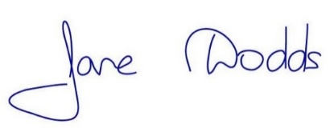
Jane Dodds MS/AS
Member of the Senedd for Mid and West Wales
Aelod Senedd dros Canolbarth a Gorllewin Cymru

